report on

“EMPLOYABILITY PORTFOLIO”

Submitted to:

**Dr Grace U. Nneji**

**Student ID: 202118010418**

**Group: L4-C3**

A mini coursework submitted in partial fulfillment of the requirements for the module of

[Information System]

­

DEPARTMENT OF cOMPUTER sCIENCe/Software engineering

OXford brookes university and Chengdu

university of technology collaborative programme

Date: 2023/3/26



[Chengdu University of Technology]

List of Contents

1. Cover Page.................................................................................................1
2. List of Contents...........................................................................................2
3. Placement Role ............................................…....................................…...3
   1. Screenshot of the website......…...........................................................3
   2. Company’s URL ......……………...........................................................4
   3. About Company ....……………...................................................…....4
   4. Roles/Responsibilities …………...................................................….…4
4. Attributes……………….……………………………………............................5
   1. Technical Skils…………...........…...........,............................................5
   2. Additional Skills…................................................................................5
5. STAR Method........………………………......................................….....…..6
   1. Attribute 1…………....…..............................................................…….6
   2. Attribute 2........................................................................….......…......7
   3. Attribute 3….........................................................................…......…..7
   4. Attribute 4….........................................................................….......….8
   5. Attribute 5….........................................................................…........…8
6. Action Plan….....……............................................................................….9
7. References…………………..............................................................…....10

# Placement Role

* 1. **Screenshot of the Website**

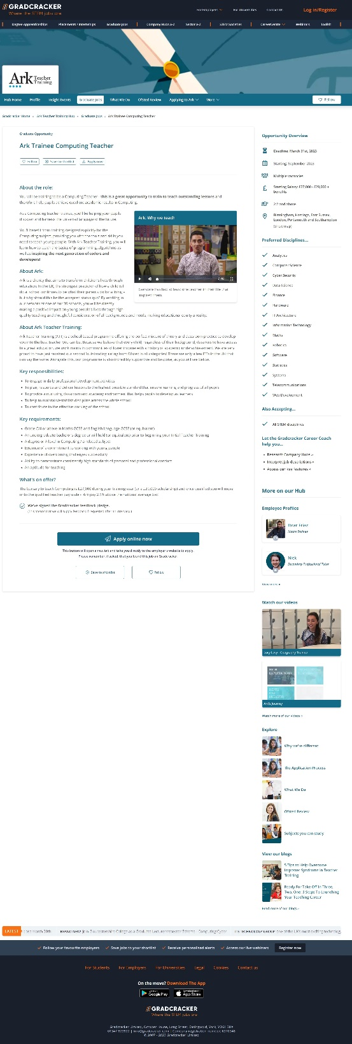

* 1. **Company’s URL**

<https://www.gradcracker.com/hub/969/ark-teacher-training>

* 1. **About Company**

**Name:** Ark

**Details:** Ark is a charity that aims to change the lives of children through education. The best predictor of children's performance at school in the UK remains their parents' occupation - but why should this be the accepted status quo? By working at one of our 39 schools, you will directly make a positive impact on young people's lives through high quality teaching and thoughtful consideration of all backgrounds and needs, making educational equity a reality.

* 1. **Roles/****Responsibilities**

**Roles:** You will be training to be a Computing Teacher - this is a great opportunity to train to teach outstanding lessons and therefore help pupils achieve excellent academic results in Computing. As a Computing teacher trainee, you’ll be helping your pupils discover and harness the universal language of the future. You’ll benefit from training designed explicitly for the Computing subject, providing you with the tools and skills you need to teach young people. With Ark Teacher Training, you will learn how to teach the basics of programming, algorithms as well as inspiring the next generation of coders and developers!

**Responsibilities:**

* To engage in daily professional development activities
* To plan, resource and deliver lessons to the highest possible standard that ensure learning and progress of all pupils
* To provide a nurturing classroom and academy environment that helps pupils to develop as learners
* To help to maintain/establish discipline across the whole school
* To contribute to the effective working of the school

# Attributes

* 1. **Technical Skills**
* Basic programming knowledge
* Basic knowledge of algorithms
  1. **Additional Skills**
* An undergraduate bachelor’s degree or will hold (or equivalent) prior to beginning your Initial Teacher Training
* A degree or A level in Computing / a related subject
* The degree level is 2:2 or above
* Experience of overcoming challenges successfully
* Ability to demonstrate consistently high standards of personal and professional conduct
* An aptitude for teaching
* Love your major
* Dedication and community spirit
* Evidence of a commitment to working with young people

# STAR method for each attribute

* 1. **Attribute 1:** Basic programming knowledge

**S:** I am a sophomore majoring in computer science and technology, learning basic programming knowledge (python).

**T:** The course will be followed by an exam on basic programming knowledge, which will assess the ability to write code by hand and programming concepts.

**A:** Because I have the basic knowledge of programming and a comprehensive understanding of knowledge points through the careful completion of courses, I can make a complete and quick self-review plan. This included reviewing the course ppt, repracticing the course work, and finally performing the self-simulation test, which achieved good expected results.

**R:** Due to my full preparation, I completed each question accurately and quickly in the course exam and got an A+ grade. (Reference 3)

* 1. **Attribute 2:** An aptitude for teaching

**S:** I was a volunteer teacher in rural areas during the winter vacation of my freshman year. I was responsible for teaching students math knowledge.

**T:** Our headmaster asked me to improve the students' math knowledge and to get a better average on the final exam than last year.

**A:** Since I had no educational experience before, I turned to professional teachers and the Internet for educational methods. In combination with the reality, I took measures such as strictly requiring students to complete their daily homework, setting weekly tests and caring about the learning situation of backward students, so as to improve their learning enthusiasm.

**R:** Because of my targeted approach and the students' hard work, we achieved better final grades together (an average increase of 5%). (Reference 4)

* 1. **Attribute 3:** Dedication and community spirit

**S:** In college, I was a member of the university volunteer organization and had the opportunity to participate in various community volunteer services.

**T:** The counselor organized a nursing home visit, but without funding, most people didn't want to go.

**A:** I want to do every volunteer service because I have a strong sense of dedication and community spirit, so I asked and convinced the government welfare officials to provide funds for our activities, and then recruited three members of the volunteer organization to go to the nursing home with me. I'm responsible for the overall planning and communication with the seniors.

**R:** Finally, because of our dedication and serious working attitude, we successfully completed the volunteer activity and got the certificate of outstanding volunteers. (Reference 6)

* 1. **Attribute 4:** Experience of overcoming challenges successfully

**S:** I am a senior three student who took a year and a half off school due to illness.

**T:** I will take the college entrance examination two months later, which will examine all the knowledge of high school.

**A:** Because of my suspension from school, I had to review all the knowledge of high school in two months. So I made my own review plan, set study goals every day, allocated study time to each subject, and spent 1 hour more studying than the average student.

**R:** Through my targeted independent review and persistent efforts, my college entrance examination score exceeded 85% of the students in the province and I was admitted to a key university. (Reference 5)

* 1. **Attribute 5:** Evidence of a commitment to working with young people

**S:** I was a computer science and technology major in my freshman year.

**T:** I'm going to take part in the mathematical modeling contest for college students, but I need eight players.

**A:** Because I want to work with young people, I formed a team with 8 young people from different schools and different majors and served as the vice leader. During the competition, I was responsible for making the schedule and ensuring that the players completed the stage tasks on time, and mediating conflicts for the players.

**R:** Under my coordination, every young team member plays a role and gets along well with each other. (Reference 7)

# Action Plans

|  |  |  |  |
| --- | --- | --- | --- |
| Future actions | Time-frame | Potential future result | Possible challenge |
| Completed the online algorithm course of Tsinghua University on the Chinese MOOC and obtained the certificate of qualification | 2023.7-2024.1 | Good knowledge of basic algorithms | Lack of self-control  The course is difficult |
| I worked hard in school to learn the course content, completed the course tasks on time after class, and made and completed the self-improvement plan according to the actual situation at home during the vacation | Now-2025.6 | The degree level is 2:2 or above | Courses vary widely;  Long time span;  Lack of self-awareness;  Lack of self-control;  Study for IELTS; |

**6. References**

<https://www.gradcracker.com/>

<https://www.gradcracker.com/hub/969/ark-teacher-training>

Leece, R. (2005). The role of e-portfolios in graduate recruitment. Australian Journal of Career Development, 14(2), 72–79. <https://doi.org/http://dx.doi.org/10.2255/1038-4162.14.2.0028>

Pate, H., & Main, S. (2017). Constructing the pathway: Supporting student employability in an Education program. ePortfolio Forum: Owning, supporting and sharing the journey. Brisbane: eLearning Services.

Simatele, M. (2015). Enhancing the portability of employability skills using e-portfolios. Journal of Further and Higher Education, 39(6), 862–874. <https://doi.org/10.1080/0309877X.2014.953461>

Stevens, H. (2008). The impact of e-portfolio development on the employability of adults aged 45 and over. Campus-Wide Information Systems, 25(4), 209–218. <https://doi.org/10.1108/10650740810900658>

Woodley, C., & Sims, R. (2011). EPortfolios, professional development and employability: Some student perceptions. Campus-Wide Information Systems, 28(3), 164–174. <https://doi.org/10.1108/10650741111145698>